**A. Research Goal**

The goal of this study is to descriptively characterize epigenetic patterns in subjects with atrial fibrillation (AF: ICD9 code: 427.31), compared to subjects without this diagnosis among the Personalized Medicine Research Project (PMRP) cohort. The overarching premise of this study states that *distinctive patterns in degree of methylation across the genome will be observable leading up to incidence and diagnosis of atrial fibrillation.* Further*, epigenetic changes such as changes in methylation density may be especially prominent in genes that contribute risk to disease emergence.*The current study is exploratory and seeks to provide preliminary data to inform planning of further studies. To pilot test proof of concept, characterization of methylation patterns at a single point in time (i.e., time of enrollment in PMRP) in the context of date of disease emergence and presence of other identifiable known risk factors for AF, is proposed.

**B. Specific Aims**

**Specific Aim 1: Characterize history of AF emergence among PMRP subjects and phenotype cases and controls for comorbidities for purposes of matching**

The strategy of this aim is to identify representative study eligible subjects for each of the following study sub-cohorts enrolled in PMRP with specimens available in the PMRP biobank: 1) subjects with a prior history of AF at time of enrollment in PMRP; 2) subjects with emergent AF following enrollment in PMRP; 3) subjects with no history of AF pre or post enrollment in PMRP to present date. The aim seeks to characterize the temporal window between and time of sample collection on enrollment in PMRP and AF emergence based on first diagnosis (ICD9 code: 427.31) of AF in the electronic medical record, and validated on a different date: i.e., applying ‘rule of two.’ Presence of known risk factors for AF will be characterized for purposes of matching cases and controls on as many parameters as possible. Smoking and family history of AF will also be collected.

**Specific Aim 2:** **Characterize epigenetic profiles of representative subjects from the three sub-cohorts defined in Specific Aim 1 by epigenetic genome wide association study (EWAS) approach.**

Subjects from each group will be classified and strategically chosen to represent the longitudinal trajectory of time to disease emergence in order to examine dynamics of methylation across various temporal windows as defined by time of AF diagnosis relative to time of PMRP enrollment. DNA from participants developing AF post PMRP enrollment on the same time line will be stratified into two age groups and pooled for epigenetic profiling. Control subjects will be matched as closely as possible to selected cases based on age range (+/-comorbidities present at time of AF emergence, sex, and smoking status; and pooled separately for epigenetic profiling (see Figure 1). For the pre-enrollment group, subjects will be selected to reflect the age range represented in the post enrollment group to reduce confounding that may occur if age ranges among subjects whose AF diagnoses predate PMRP enrollment date were fundamentally different from those with emergent AF post enrollment.

**Specific Aim 3:** **Characterize methylation patterns on currently proposed candidate genes or regions associated with AF and define any new epigenetic regions exhibiting dynamic methylation patterns.**

Epigenetic patterns will examined in light of other known patterns that have been defined in association with aging or other diseases (e.g. diabetes mellitus).

**C. Background**

AF is the most prevalent cardiac arrhythmia and increasingly, evidence is mounting supporting a genetic contribution to susceptibility. Onset of cardiac arrhythmia has been attributed to dysregulation of transmembrane electrical conduction and atrial electrical remodeling in genes encoding ion channels. While there are multiple subtypes of atrial fibrillation, **the current proposal will focus on AF with ICD9 code 427.31, because this diagnosis is well represented (n=1764 cases) among ~20,000 PMRP subjects currently enrolled**.

**Some factors contributing risk to AF emergence have been defined and include advancing age, sex, presence of comorbidities including hypertension, obesity, ischemic heart disease, myocardial infarction, valve diseases, hyperthyroidism, environmental exposures including smoking, and family history.** A genetic component is operable in both hereditary and non-heritable AF (Sinner 2011). Presently genetic association has been identified for three candidate genes and 17 causal mutations in the context of a familial history of various manifestations of AF. Further, 7 common variants and SNPs in 11 genes have been preliminarily associated with non-familial AF but require further validation (Xiao et al 2011). To date, validated genetic loci in three chromosomal regions, including 1q21, 4q25 and 16q22, have demonstrated association with various atrial fibrillation (AF) arrhythmias (Sinner et al 2011). SNPs in 16q22 occur in the first intron of *ZFHX3*, a zinc finger homeobox, and association with cardiac function remains unclear (Sinner et al 2011). Associated SNPs at the 1q21 locus occur in the intronic region of *KCNN3* which encodes potassium channels found in tissue and are postulated to shorten atrial action potential resulting in reduction of atrial myocytes refractory period, thus predisposing to AF (Sinner et al 2011). SNPs in the 4q25 showing association are found in intergenic regions near *PITX2* and *PITX2c,* which are involved in cardiac development. (Lubitz et al 2010) Additional GWAS centered on prolonged PR interval as the ‘endophenotype’ for prediction of AF (Pfeuerer et al 2010, Holm et al, 2010) identified 7 candidate genes, but these did not achieve genome-wide significance. Other GWAS studies have shown that risk alleles may interact, with significant increases in risk noted (Lubitz et al 2010). Additional variability attributable to associated gene interaction remains to be examined. Current literature concludes that much of the heritability associated with AF remains to be defined.

Distinctive epigenetic changes have been reported in association with emergence of various diseases, including changes in methylation patterns in a risk gene-specific manner (Toperoff et al 2012, Bell,et al 2010, Bell et al 2012, Xu et al 2013). However, dynamic evolution of methylation patterns over time in the context of specific diseases largely remain to be examined. Interestingly, **examination of methylation patterns of DNA from blood cells or miRNA levels in serum has been successfully used to demonstrate clear association of epigenetic changes of genes associated with specific diseases without need to examine specific tissue.** An example includes the recent demonstration of contribution of epigenetic changes to the to the FTO gene, a gene associated with obesity, to Type II diabetes mellitus (T2DM) susceptibility (Bell et al 2010). Bell et al integrated GWAS SNP data and EWAS to specifically detect novel genotypic and epigenetic interactions in T2DM risk alleles, in a case-control design and identified haplo-specific methylation in the *FTO* susceptibility locus (Bell et al 2010). Applying a ***matched case-control study design***, utilizing ***peripheral blood***-***derived DNA*** from subjects with and without T2DM, and an ***array- based EWAS approach***, Toperoff et al further demonstrated that escalating hypo-methylation of a CpG site in the first intron of *FTO* was significantly and more strongly associated with T2DM cases than presence of sequence variants most highly associated with the disease. Toperoff used ***a pooled serum approach*** to amplify any signal across the candidate region under study. **The strategy proposed in their study has been modeled in the current study design**. Notably, these investigators further demonstrated predisposition to T2DM development in an independent cohort of younger subjects exhibiting hypo-methylation of the candidate region in a prospective study, suggesting inherent predictive potential. Finally these authors identified presence of co-localized gene enhancers and binding sites for transcriptional regulators responsive to levels of methylation in the candidate region (Toperoff et al 2012). Interestingly, a study by Lango et al which examined the combined impact of 18 candidate risk alleles (including *FTO*), reported that despite their modest collective discriminatory accuracy, stratifying subpopulation by numbers of risk alleles they encoded supported discrimination of relative risk of disease onset among the subpopulation (Lango 2008).

Examples of epigenetic changes that can impact on gene expression and regulation include changes in DNA methylation patterns, post-transcriptional modification of the histone tail protruding from the nucleosome including acetylation and methylation and microRNA regulation of DNA expression. **Several recent studies have targeted miRNA expression patterns in association with AF. Over the past 2 years, 8 miRNAs have been identified which may be associated with pathological processes contributing to atrial remodeling: miRNA-1, 21, 26, 30, 133, 328, 499 and 590 (Shi et al 2013).**

**While other epigenetic mechanisms may be involved, this study proposes to focus solely on patterns of DNA methylation** **genome wide in PMRP subjects with an AF diagnosis** **and PMRP controls with no history of AF incidence to date.** CpG islands whose establishment is regulated by CpG dinucleotide ‘beacons’, are common targets of methylation across the genome (Bell et al 2012). Some genes associated with transmembranous electrical conduction have CpG islands and were studied for changes in methylation patterns since these regions could theoretically contribute to arrhythmogenesis. Methylation is generally associated with silencing of genetic expression allegedly due to presence of the methylation blocks access to promoter binding elements (Suzuki and Bird, 2008.) Transgenomic methylation analysis of a kindred (n=31) revealed two SNPs in linkage disequilibrium in the promoter of the SCN5A gene that were associated with increased disease severity. Notably whereas differential methylation patterns of 2 CpG islands were also noted among individuals with mild and severe arrhythmia phenotypes, epigenetic analysis did not support a role for methylation changes in the SCN5A gene (Park et al 2012). Other epigenetic studies of AF to date are mainly investigations in animal models across a range of different manifestations of arrhythmias (Dugyu et al 2013).

We propose to pilot examination of methylation patterns dynamics over time by conducting EWAS on DNA from PMRP participants with an AF diagnosis and matched PMRP controls with no history of AF diagnosis using a longitudinal perspective based on date of diagnosis (see flow diagram in Figure 1 overview of the detailed study design plan.) Because published data support that methylation variability is specific to genes containing risk alleles, localization of dynamic changes in methylation over time presents opportunity to identify additional candidate genes or regions associated with AF emergence.

**Significance**

Genetic contribution to mechanisms underlying emergence of AF are not well understood. Epigenetic changes over time relative to emergence of disease offers opportunity for identification of epigenetically modified regions that may contribute to disease emergence and increase understanding of the underlying mechanisms contributing to disease development. Moreover, because of the unique PMRP resource which supports both epigenetic testing on banked DNA specimens as well as phenotypic definition of time to disease emergence and presence of other risk factors, **this pilot study is positioned to determine whether the EWAS approach using white blood cell-derived DNA will exhibit changes in methylation patterns that parallel disease emergence over time.** If informative, this approach advances the opportunity to propose more expanded studies on larger sample sizes of PMRP cases and controls to further test potential candidate genetic associations that may be suggested in this pilot study. Improved understanding of mechanisms underlying AF emergence are pivotal to defining better interventional and preventative approaches. Approaches to disease management are presently suboptimal and prevalence of AF is approaching epidemic proportions globally (Xiao 2013).

**Preliminary Data**

Data in table 1 reflect a data request placed in March of 2014. Data requested included delineation of all patients in PMRP with a diagnosis of AF by year of when the first diagnosis occurred relative to date of PMRP enrollment. Ages of patient at time of diagnosis was also requested, and age ranges pre and post were found to be comparable.

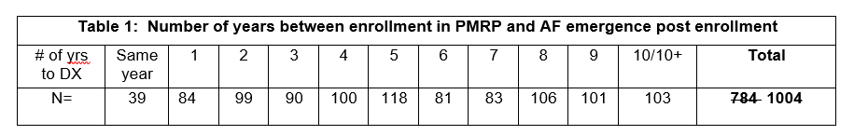

The correct roll up of the numbers is as follows:

Total # of diagnoses: 1788

Total # dx post enrollment: 1004 (correct total for table 1)

Total # with dx pre enrollment: 784

The purpose of the table is to demonstrate feasibility of estimating the relative numbers of potential cases that may be tapped and support that sufficient numbers of samples were available for inclusion in the schema proposed as proposed on p. 7.

These data support the plausibility of defining incidence date. Since subjects in PMRP largely represent

MESA residents who receive care at Marshfield Clinic, ability to capture data for these subjects relating to presence of other risk factors by screening for presence of diagnostic codes with rule of 2, is highly feasible. A similar approach will be used to characterize number of years from disease emergence to date of PMRP enrollment for subjects who developed AF *prior* to PMRP enrollment. Subjects will also be characterized for age at first diagnostic code and age at enrollment in PMRP.

Dr. Braxton, a cardio-thoracic surgeon, and study co PI with expertise in cardiac arrhythmias, is currently conducting a study to determine whether miRNA panels that have been associated with changes in levels of expression in the context of cardiac conditions, can be useful in differentiating patients at risk for developing post-operative AF (POAF) during or after coronary artery bypass grafting (CABG), if these panels are run prior to surgery. Notably **epigenetic observations relative to miRNA in the context of POAF under study by John Braxton (Co-PI) *may not be generalizable* to other subtypes of AF/cardiac arrhythmias, since they are associated with emergence of AF in a very specific context in a unique subset of patients among the broader population that develops AF.** However, his study provides an example of how epigenetic analysis may have applicability in the clinical arena in the future if such approaches can be used to distinguish at-risk patients who may benefit from alternative preoperative, inter-operative or post-operative management to minimize these risks. Analyses of study results are ongoing.

**Research Design and Methods**

*Note to Reviewers: The study design has been somewhat simplified from the original design submitted in the pre-proposal with respect to the pilot study design. We have eliminated collection of an additional blood sample from PMRP subjects to reduce study cost and instead: 1) characterize risk factors to support more complete matching of cases and controls and 2) support testing and analysis of a larger number of specimens. Aims and methods have been modified accordingly.*

The study represents a descriptive retrospective case-control pilot study design utilizing already existing stock solutions of banked DNA specimens of subjects currently enrolled in PMRP collected at time of study enrollment. Cases will be defined as PMRP subjects with a diagnostic code (ICD9 code: 427.31) corresponding to AF either prior to, or emergent post enrollment in PMRP. Control subjects are those enrolled in PMRP in the same year with no past or present history of AF (applying all ICD9 codes for AF or atrial flutter) captured in the EMR. The following overview defines the strategic approach of the study.

**Sample size:**

Since this is a pilot study, we have arbitrarily selected to conduct epigenetic screening on 20% of the population in PMRP with diagnosis of AF (ICD9 code 427.31) by rule of 2. Specifically, patients were pooled, 15 subjects/time point (two year windows), as shown in the study schema in **Figure 1**. This schema illustrates plating of 15 cases/well and 15 matched controls (10 cases/10 controls at time zero) x5 time points of AF emergence pre and post PMRP enrollment across 2 age tiers reflecting the age range represented in each year. Thus, the **total study n= 640,** (320 cases and 320 matched controls).

**Specific Aim 1:** **Phenotypically characterize history of AF emergence among PMRP subjects**

Since matching of cases and controls is an important aspect of the study design, phenotypic characterization of the cases and matching controls is of sufficient importance to warrant inclusion as a separate specific aim.

**Matching:**

Controls and cases will be matched by: 1) year of enrollment; 2) sex; 3) age (+/- 2 years of the age of the case at the time of AF diagnosis) and presence of the following known risk factors for AF: hypertension, myocardial infarction, ischemic heart disease, heart valve disease, obesity, hyperthyroidism, smoking (use information provided on PMRP intake form and EMR data). Electronic screening of the PMRP cohort for ICD 9 code 427.31 will be used to identify AF cases, applying requirement for ‘rule of two’ occurrences of the code, This strategy will also be applied for characterization of ICD9 codes corresponding to comorbid risk factors among all subjects in PMRP. Potential cases emergent post PMRP enrollment will be matched to controls based on age range at time of diagnosis (+/- 2 years). Subjects with AF diagnosis prior to PMRP enrollment chosen for inclusion in testing pool in any given year will be chosen to reflect ages of subjects selected for testing post enrollment in order to minimize confounding that may occur if subjects with AF diagnosis prior to PMRP enrollment, are found to represent an older subpopulation. Other risk factors on which subjects will be matched include sex., and to the greatest extent possible, smoking history and as many comorbid risk factors as possible. Smoking history will be based on intake forms at time of enrollment in PMRP. Obesity will be determined by calculating body mass index at the time of AF event. All ICD9 codes for AF and comorbid diagnoses identified electronically for cases and matched controls will be validated by manual abstraction (See Data abstraction form, Appendix). Self-reported family history of AF will be captured based on information provided on the PMRP intake form but will not be a factor in matching.

**Specific Aim 2: Characterize epigenetic profiles of representative subjects from the three sub-cohorts defined in Specific Aim 1 by epigenetic genome wide association study (EWAS) approach.**

Study approval will be sought from the PMRP oversight committee before study is commenced. **Figure 1** depicts an overview of the study population and testing design. All selected DNA samples will be encrypted with a study code to blind the testing laboratory.

***Specific Aim 3: Identify patterns of epigenetic expression over time with special emphasis on candidate genes. Define novel loci based on epigenetic expression patterns.***

Since we recognize that aging impacts on epigenetic expression, cases and controls will be matched by age range, (+/- 2 years), to the case at the time of AF diagnosis. Further, in each year, the study design includes investigation of expression patterns in two age group: Specifically, DNA pools will be created (15 cases or controls/ pool) defined by year of emergence at 0, 1-2, 3-4,5-6, 7-8, 9-10+ in one of two tiers: *youngest* ages in each test interval or or *oldest* ages in each year of diagnosis, with selection of appropriate individuals for inclusion supported by representation at each end of the age range with highest matching potential between cases and controls).

Arrays are set up based on a 48 well layout in a 96 well plate. A 96 well plate will be prepared by Core laboratory personnel. Equal quantities of DNA from 50ng/μl stock solutions of 7 phenotypically-characterized individuals per well who match the phenotype in the plate layout below will be combined. Functional Genomics Testing Facility (University of Chicago, Chicago II) requires 40μl of a 1μg of DNA of the pooled DNA to be placed in its designated well (see schematic below). There will be one well available per array for duplicate plating of a randomly selected well to serve as a quality control check for each assay to assess reproducibility of assay results. Plated DNA will be submitted to Functional Genomics Testing Facility which has been contracted for epigenetic testing overseen by its Operational Director, Dr. Pieter Faber (***see biosketch in the Appendix for an overview of his credentials***). One array (2 plates/array) will accommodate testing a total of 24 samples per array set. (A detailed overview, graphic and description of the Infinium HumanMethylation450 BeadChip Kit (Illumina, San Diego, CA) is found in the **appendix**).

**Infinium HumanMethylation450 BeadChip Kit: Assay overview**

An overview of the methylation assay is summarized in **Appendix.** The user’s manual with a step by step description of the methodological approach to the assay can be accessed at the following link: <http://supportres.illumina.com/documents/documentation/chemistry_documentation/infinium_assays/infinium_hd_methylation/inf_hd_meth_assay_ug_15019519_revb.pdf>. Briefly, the methylation array involves a 2-step process in which the first step is bisulfite conversion of unmethylated cytosine in the DNA into uracil . T his permits differentiation between methylated and unmethylated cytosine in interpretation of the array results. Thereafter each sample is run on the array which tests ~450,000 CpG positions for methylation status.

**Specific Aim 3:** **Characterize methylation patterns on currently proposed candidate genes or regions associated with AF and define any new epigenetic regions exhibiting dynamic methylation patterns.**

Analysis of the epigenetic expression patterns will be conducted utilizing freely available software specifically created for data analysis of Illumina’s Infinium HumanMethylation450 BeadChip Kit. The Minfi User’s guide and overview of CpG loci identification strategy has been included in the appendix to provide an overview of the program and its capabilities. Briefly, the Infinium 450 array’s measurements are made with a single probe and methylated and unmethylated sites are distinguished using 2 colors. The program distinguishes differentially methylated positions (DMPs) in different sets of samples. Data are checked via density plots for outlier samples, data is ‘normalized’ in a preprocessing step to generate a MethylSet data set to obtain methylation estimates. The readings also undergo a quality assessment, and normalization, if required before data are presented as multi-dimensional scaling (MDS) plots allow for comparisons among samples. Data returned following epigenetic testing will already have normalization and background subtraction performed. Data can be subjected to categorical phenotyping by application of an F test to identify positions exhibiting differential methylation. Methylation levels can also be plotted at individual positions and data output is reported in a table format and may be sorted by p values calculated for the DMPs. Continuous phenotypes can also be generated as needed, applying regression analysis when methylation level varies with a continuous covariate (e.g. presence of a confounding risk factor). However, the present study is more focused on descriptive analyses and observational study of potential patterns revealed by epigenetic analysis.

**Statistical Analysis Plan:**

**Specific aim 1:** Descriptive statistics will be carried out to summarize characteristics of subjects with AF which will be presented in box plot formats for representing quantitative measures and frequency tables for categorical measures. Algorithms would be developed to classify the patients into their defined subgroups. Percent of cases for which complete matching was accomplished will be characterized.

**Specific aim 2:** Analyses of epigenetic data of subjects pooled in each year defined longitudinally between time of AF emergence and time from PMRP enrollment would employ an R package, called “minfi” (http://www.bioconductor.org/packages/release/bioc/html/minfi.html) which is specifically designed to analyze Infinium HumanMethylation450 BeadChip Kit assay data. For each experiment, the data will be analyzed independently, including pre-processing, quality assessment, and identification of dynamic methylation loci and visualization of the data.

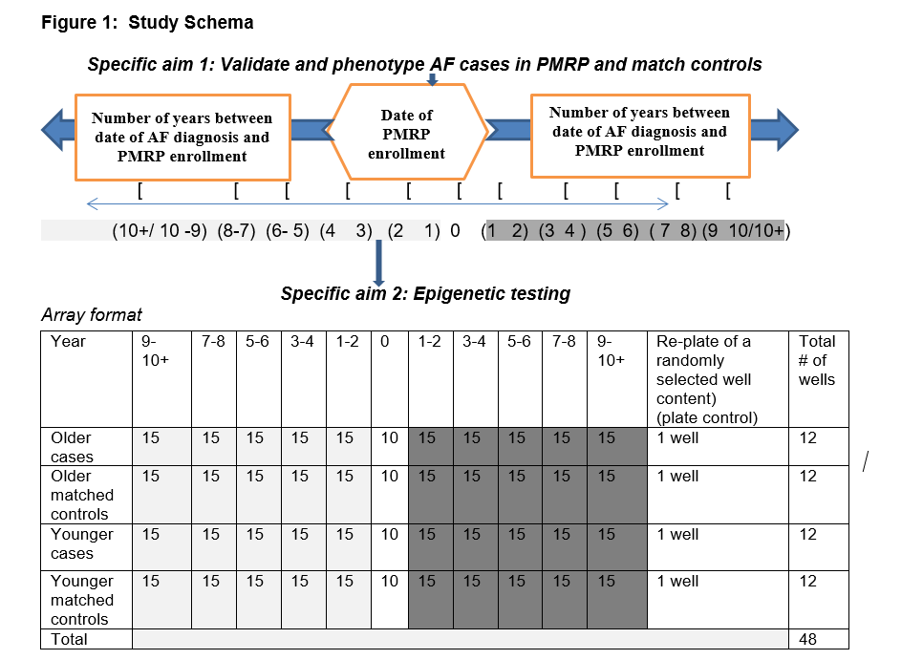

**Specific aim 3**: Based on the individually analyzed data from aim 2, descriptive analyses would characterize patterns of changes in epigenetic patterns longitudinally, 1) at candidate AF-associated genes/regions (Sinner et al 2011) (also, see Background, p.2, paragraph two for an overview of the previously defined genetic regions of interest), 2) compared to patterns defined for other clinical conditions to date, (Duygu et al 2013) and 3) compared to epigenetic patterns associated with aging (Tsai et al 2012, Ben-Avraham et al 2012, Hannum et al 2013). The study design also supports comparison of patterns across groupings of patients over time as defined by number of years between diagnosis of AF and time of enrollment in PMRP. Finally, new screening of data would be undertaken to identify any novel, as yet undefined regions that may exhibit variability in methylation and support hypothesis generation for future studies.

**Study Limitations**

The current study is a pilot and thus is not designed to achieve statistical power, but rather to qualitatively examine dynamics of epigenetic expression patterns associated with AF emergence over time to the greatest extent possible in the context of the current study design. One limitation is that only one DNA sample from a single time point is available. However, based on a previous study by Aran et al (2011) who demonstrated efficacy of pooled DNA in distinguishing epigenetic patterns over background, and given the capacity to carefully phenotype individuals, we anticipate that we will be able to reconstruct longitudinal epigenetic patterns based on a single time point sample supported by knowledge of patient history at time of disease emergence. It is further anticipated that the results will inform power calculations and sample size estimations for future studies.

The results of this study are not generalizable beyond the specific AF diagnosis under study, to other types of AF. Further, while adjustment for confounding will be made to the greatest extent possible, the impact of the presence of other comorbidities and environmental factors on methylation patterns is unknown and could potentially still contribute some confounding to interpretation of methylation patterns. However, Toperoff et al (2012) successfully defined hypomethylation of the FTO gene in a longitudinal study of subjects who developed DM without matching for all potential risk factors and was nonetheless able to distinguish epigenetic patterns very specific to T2DM.

Due to budget constraints, samples will only be run once by an established testing laboratory with proper inclusion of array controls and quality control measures. Results from this study will need to be validated in a larger sample size in the future. Alternative methodological approaches to measure methylation status are available, (MALDI mass spectrometry for nucleic acid analysis, for example (Gao 2013)), and may be employed in a future study to validate the outcomes of the current study or future studies. Aging is known to be associated with genome-wide changes in epigenetic expression. Epigenetic studies of methylation patterns distinctly associated with aging have been published (Tsai et al 2012, Ben-Avraham et al 2012, Hannum et al 2013) and therefore we expect to be able to distinguish methylation patterns associated with aging and those associated with AF because of the case control design of the study. Further, we are examining epigenetic patterns in oldest and youngest individuals across a longitudinal window of disease emergence encompassing pre, emergent and post the collection time point of the DNA sample, so whether variability in epigenetic expression in younger and older patients can be examined both independently and comparatively.

**External Collaborators (N/A)**

**Timeline**

**Budget (See attached)**

**Budget Justification (See attached)**

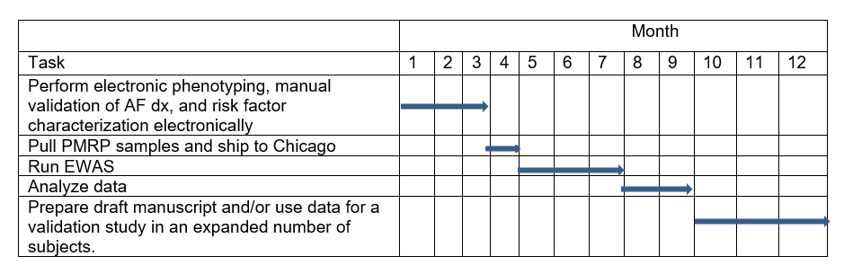**Literature Cited**

Aran D, Toperoff G, Rosenberg M, Hellman A. (2011) Replication timing related and gene body specific methylation of active human genes. Hum Mol Genet 20: 670-680

Bell CG, Finer S, Lindgren CM, Wilson GA, Rakyan VK, et al (2010) Integrated genetic and epigenetic analysis identifies haplotype-specific methylation in the *FTO* type 2 diabetes and obesity susceptibility locus. PLOS one 5:e14040 doi:10.1371/journal.pone.0014040.

Bell CG, Wilson GA, Butcher LM, Roos C, Walter L, Beck S. (2012). Human-specific CpG “beacons” identify loci associated with human-specific traits and diseases. Epigenetics 7: 1188-1199.

Ben-Avraham D, Muzumdar RH, Atzmon G (2012) Epigenetic genome wide association methylation in aging and longevity. Epigenomics 4: 503-509.

Duygu B, Poels EM, da Costa Martins PA (2013). Genetics and epigenetics of arrhythmia and heart failure. Frontiers in Genetics Oct 30; 4:219. eCollection 2013.

Gao X, Tan BH, Suqreu RJ, TangK. (2013) Maldi mass spectrometry for nucleic acid analysis. Top Curr Chem 331:55-77.

Hannum G, Guinney J, Zhao L, Zhang L, Hughes G, et al. (2013) Genome wide methylation profiles reveal quantitative views of human aging rates. Mol Cell 49: 359-367.

Holm H, Gudbjartsson, Arnar DO, Thorleifsson G, Thorgeirsson G, Stefansdottir H et al. (2010) Several common variants modulate heart rate, PR interval, and QRS duration. Nat Genet 42:117-122.

Lango H, the UK Type 2 Diabetes Genetics Consortium, Palmer CAN, Morris AD, Zeggini E et al (2008) Assessing the combined impact of 18 common genetic variates of modest effect sizes on Type 2 diabetic risk. Diabetes 57: 1329-3135.

Lubitz S, Sinner M, Lunetta K, Makino S, Pfeufer A, et al (2010) Independent susceptibility markers for atrial fibrillation on chromosome 4q25. Circulation122: 976-984.

Park Jk, Marin LJ, Xhang X, Jegga AG, Benson DW. (2012) Genetic variants in SCN5A promoter are associated with arrhythmia phenotype severity in patients with heterozygous loss of function mutation. Heart Rhythm 9: 1090-1096.

Pfeurer A, Van Noord C, Marciante K, Arking De, Larson MG, Smith Av, et al (2010). Genome wide association study of PR interval. Nature Genet 42:153-159.

Shi KH, Tao H, Yang JJ,, Wu JX, Xu, SS Zhan HY (2013). Role of microRNAs in atrial fibrillation: new insights and perspectives. Cell Signal 25: 2079-2084.

Sinner MF, Ellinor PT, Meitinger T, Benjamin EJ Kaab S. (2011) Genome wide association studies of atrial fibrillation: past, present and future. Cardiovascular Research 89: 701-709.

Suzuki MM and Bird A (2008). DNA methylation landscapes: provocative insights from epigenomics. Nat Rev Genet. 9: 465-476.

Toperoff G, Aran D, Kark JD, Rosenberg M, Dubnikov T et al (2012) Genome-wide survey reveals predisposing diabetes thype 2-related DNA methylation variations in human peripheral blood. Hu Molec Genet 21:371-383.

Tsai P-C, Spector TD, Bell JT. (2012) Using epigenome-wide association scans of DNA methylation in age-related complex human traits. Epigenomics 4: 511-526.

Xiao J, Liang D Chen H 2011 The genetics of atrial fibrillation: from bench to bedside. Ann Rev Genomics Hum Genet 12:73-96.

Xiao J, Shen Z, Yang, Y-Q, Sluijter J Das S. Genetic and Epigenetic Basis of arrhythmia and heart failure. [http://www.frontiersin.org/epigenomics_and_epigenetics/researchtopics/genetic_and_epigenetic_basis_o/904 2013](http://www.frontiersin.org/epigenomics_and_epigenetics/researchtopics/genetic_and_epigenetic_basis_o/904%202013)

Xu X, Su S, Barnes VA, De Miguel C, Pollock J, Ownby D, et al. (2013) A genome wide methylation study on obesity: differential variability and differential methylation. Epigenetics 8: 522-533.

**Biosketches (see attached)**